Employee Resources

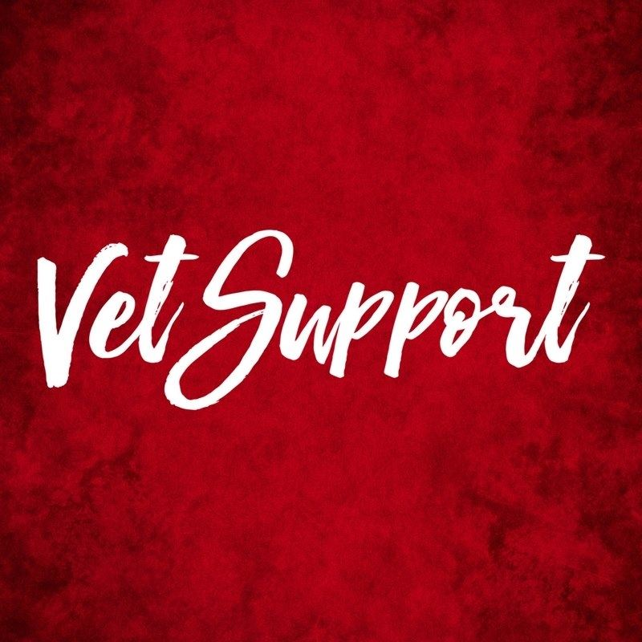
At ABC Animal Hospital we care about your physical and emotional well-being. The work that you do every day can wear on any professional. Below are a list of resources we want to make sure our family @ ABC Animal Hospital is aware of, and has access to. At any time you can reach out to the resources below and be sure that your conversations are 100% confidential. Please also know that we are available should you need to talk to us.

Resource | Information | About
Employee Assistance Plan | Plan #:  Contact: | An EAP is a confidential way of getting help on many things that may effect your health, mental or emotional well-being.
Counseling Through Health Plan | Plan #:  Contact:
Local Therapist | Inform the number below that you work @ ABC Animal Clinic.  Contact:
Crisis Text Line | Text “HOME” to 741741 | This is a support line that is crisis support exclusively through text messaging, 24/7.
National Suicide Prevention Hotline | 1-800-273-8255 | A 24/7 confidential contact for those that need support in preventing and/or managing a crisis.

